ASSIGNMENT-DIGITAL MARKETING

Name | PRANESH KARAN M
Reg No | 962820106309
NM ID | E9D90702A7E3C3982644A0EE322C7054
Date | 22-10-2023

- Create a blog or website using Blogspot and WordPress. Customize the theme design and post new article with 500 words.

Link: https://www.blogger.com/blog/posts/2898579800504617566?bpli=1&pli=1

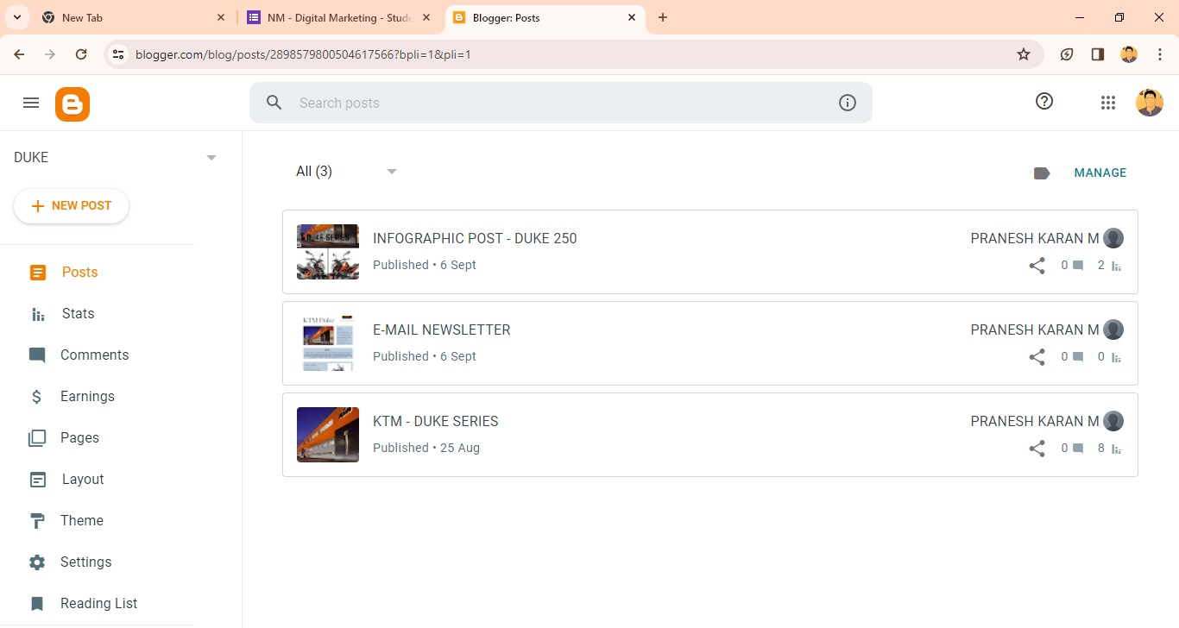

Link: https://www.blogger.com/blog/post/edit/2898579800504617566/174583895694 2259548

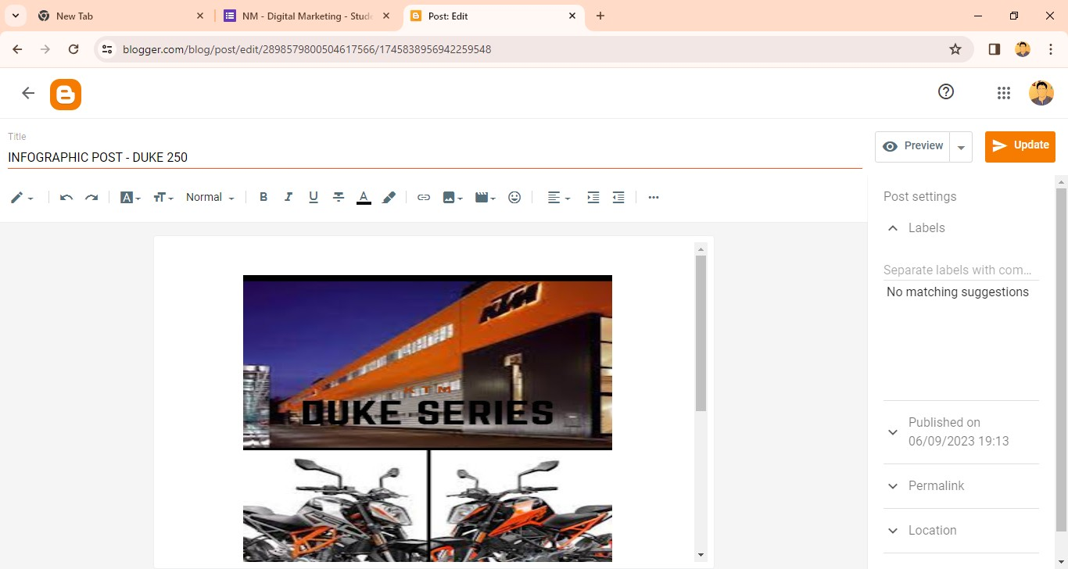

Link: https://wordpress.com/home/224974724?showLaunchpad=true
Link: https://pkduke250.wordpress.com/wp-admin/site-editor.php?canvas=edit

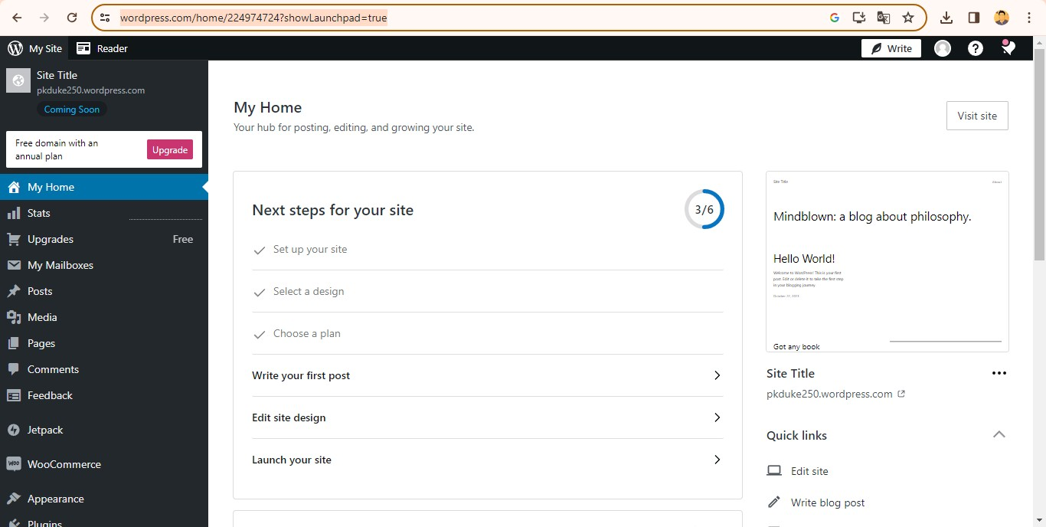

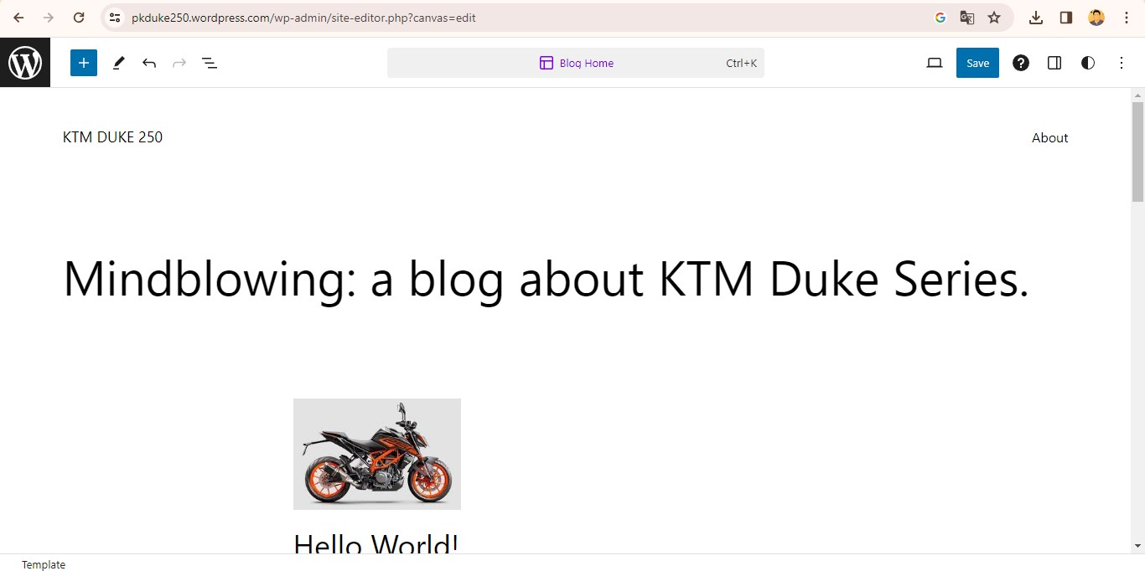

- Create a new facebook page and post one social media poster for your brand.

Link: https://m.facebook.com/story.php?story_fbid=pfbid08vmC7h7fTe8hD5Kz6dSjb xn1tkYEXL2kaTjeRC1Q8GpG7eoq6mmcSfBXQ9kJ8RiBl&id=615504792035 73&mibextid=Nif5oz



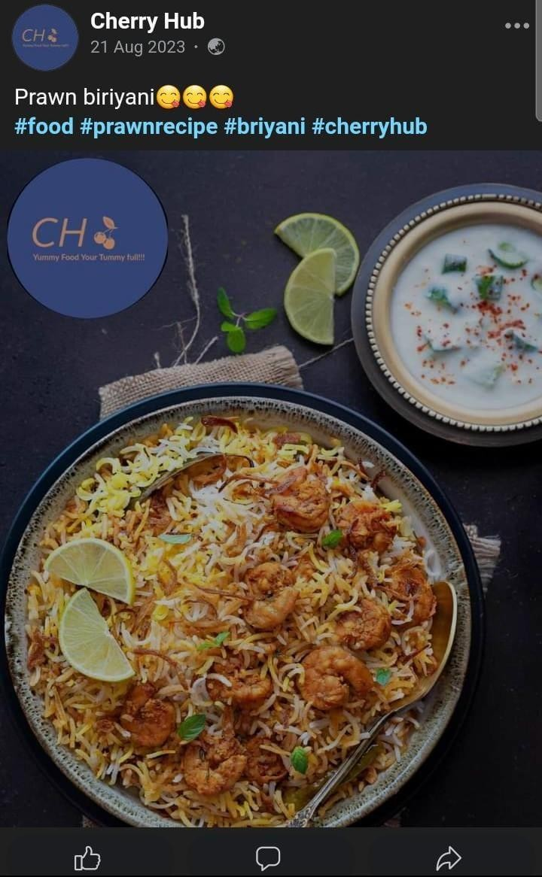

- Create and design a social media advertisement poster using canva Link:
https://www.canva.com/design/DAFx9jbqZzE/8gRpX-yuQwAzg-XZrriH1g/vie w?utm_content=DAFx9jbqZzE&utm_campaign=designshare&utm_medium=li nk&utm_source=editor

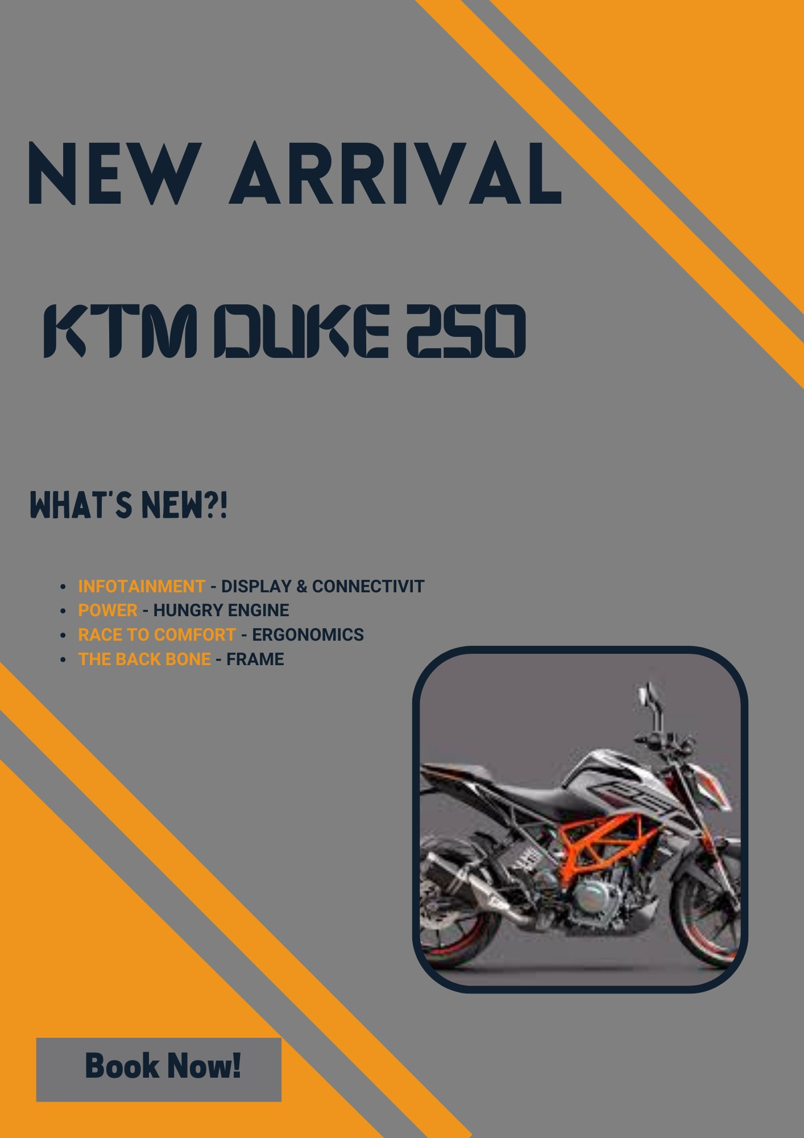

- Create email newsletter design using MailChimp or canva tool. Link:
https://pkduke250.blogspot.com/2023/09/e-mail-newsletter.html

